Credit Risk Prediction System using Machine Learning

Project Id: AIML-8

Name : Vaibhavi Thapliyal(Team Leader)
Class Roll Number: 76
University Roll Number : 2028897
Section and Group: Q Group 2

Name : Naina Vashishtha
Class Roll Number: 53
University Roll Number : 2028774
Section and Group: Q Group 2

Name : Samiksha Gurung
Class Roll Number:66
University Roll Number : 2028836
Section and Group: Q Group 2

- Problem Description 3
- Architecture 4
- Models model 5
- Evaluation metrics used 6
- Preliminary Results and Visualizations 8
- References 11

1.Problem Description
The Credit Risk Prediction System is a machine learning-based application developed to predict whether a customer is likely to default on a loan. Financial institutions face significant risks due to loan defaults, making it essential to analyze customer data effectively and make informed decisions.
This project uses customer financial and demographic data such as income, credit score, employment type, loan details, and other attributes to build a predictive model. The system automates the process of analyzing data, identifying patterns, and predicting loan default outcomes.
Machine learning techniques such as data preprocessing, handling class imbalance using SMOTE, classification using Logistic Regression, and model evaluation are applied to ensure accurate and reliable predictions. This helps in reducing financial risks and improving decision-making processes.

- Architecture

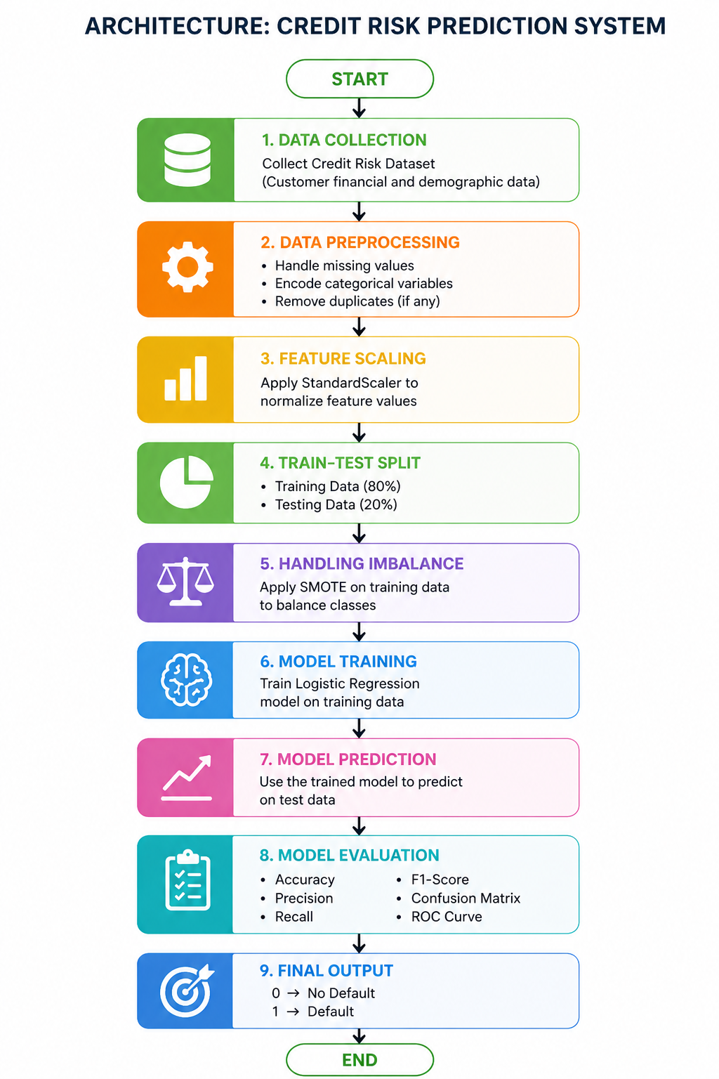

Fig.1 Sample flow diagram.

2.Models Used(Applied/ Planned)
1. Logistic Regression
Logistic Regression is a supervised machine learning algorithm used for binary classification problems. In this project, it is used to predict whether a customer will default on a loan (1) or not (0).
The model works by estimating the probability of an input belonging to a particular class using a sigmoid function. Based on this probability, the output is classified into either 0 (non-default) or 1 (default).
Why Logistic Regression was used:
- Suitable for binary classification problems
- Simple and easy to interpret
- Provides probability-based predictions
- Efficient for structured datasets

2. SMOTE (Synthetic Minority Oversampling Technique)
SMOTE is a data preprocessing technique used to handle class imbalance in the dataset. Initially, the dataset contained more non-default cases than default cases, which could lead to biased predictions.
SMOTE generates synthetic samples for the minority class (default cases) by creating new data points based on existing ones. This helps in balancing the dataset and improving model performance.
Why SMOTE was used:
- To balance the dataset
- To prevent model bias toward the majority class
- To improve prediction of minority class (defaulters

3. StandardScaler (Feature Scaling)
StandardScaler is used to normalize the dataset by scaling features to have mean of 0 and a standard deviation of 1.
Since features like income and credit score have different ranges, scaling ensures that all features contribute equally to the model and improves convergence of Logistic Regression.
Why StandardScaler was used:
- To bring all features to the same scale
- To improve model performance
- To help Logistic Regression converge faster

3.Evaluation Metrics Used
1. Accuracy
Accuracy measures the overall correctness of the model by calculating the proportion of correctly predicted instances out of the total instances.
$$Accuracy=\frac{TP+TN}{TP+TN+FP+FN}$$
Where:
- TP = True Positives
- TN = True Negatives
- FP = False Positives
- FN = False Negatives
Explanation:
It tells how many predictions made by the model are correct.
Limitation:
Accuracy may not be reliable when the dataset is imbalanced, as the model can achieve high accuracy by predicting the majority class.

2. Precision
Precision measures the proportion of correctly predicted positive observations out of all predicted positive observations.
$$Precision=\frac{TP}{TP+FP}$$
Explanation:
It tells how many of the predicted defaulters were actually defaulters.
Importance:
Useful when the cost of false positives is high.

3.Recall
Recall measures the proportion of actual positive cases that were correctly identified by the model.
$$Recall=\frac{TP}{TP+FN}$$
Explanation:
It tells how well the model identifies actual defaulters.
Importance:
Very important in this project, as missing a defaulter can lead to financial loss.

Very important in this project, as missing a defaulter can lead to financial loss.

4. F1 Score

F1 Score is the harmonic mean of precision and recall.
$$F1=\frac{2×Precision×Recall}{Precision+Recall}$$
Explanation:
It provides a balance between precision and recall.
Importance:
Used when both false positives and false negatives are important

5. Confusion Matrix

A confusion matrix is a table used to evaluate the performance of a classification model by comparing actual and predicted values.

 | Predicted No | Predicted Yes
Actual No | True Negative (TN) | False Positive (FP)
Actual Yes | False Negative (FN) | True Positive (TP)
Explanation:
- True Positive: Correctly predicted defaulters
- True Negative: Correctly predicted non-defaulters
- False Positive: Incorrectly predicted default
- False Negative: Missed defaulters
Importance:
It provides a complete understanding of model performance.

5. Preliminary Results and Visualizations

Fig 2:

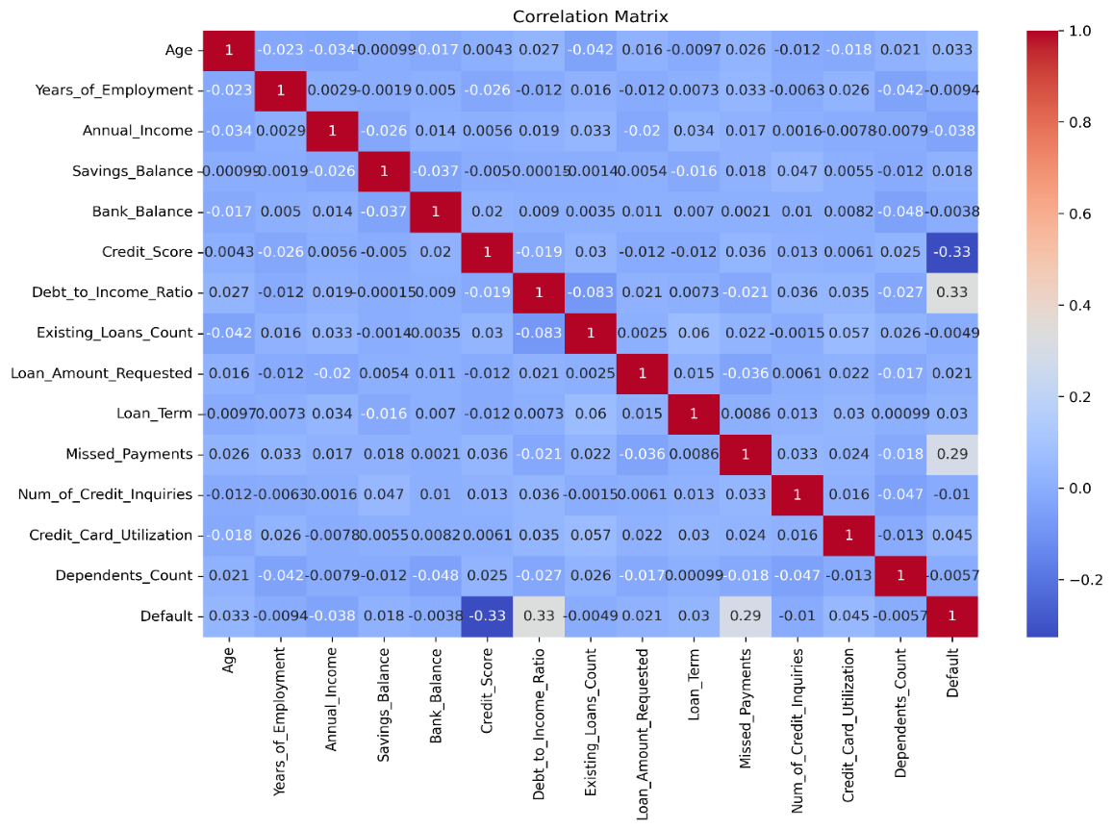

Fig 3:

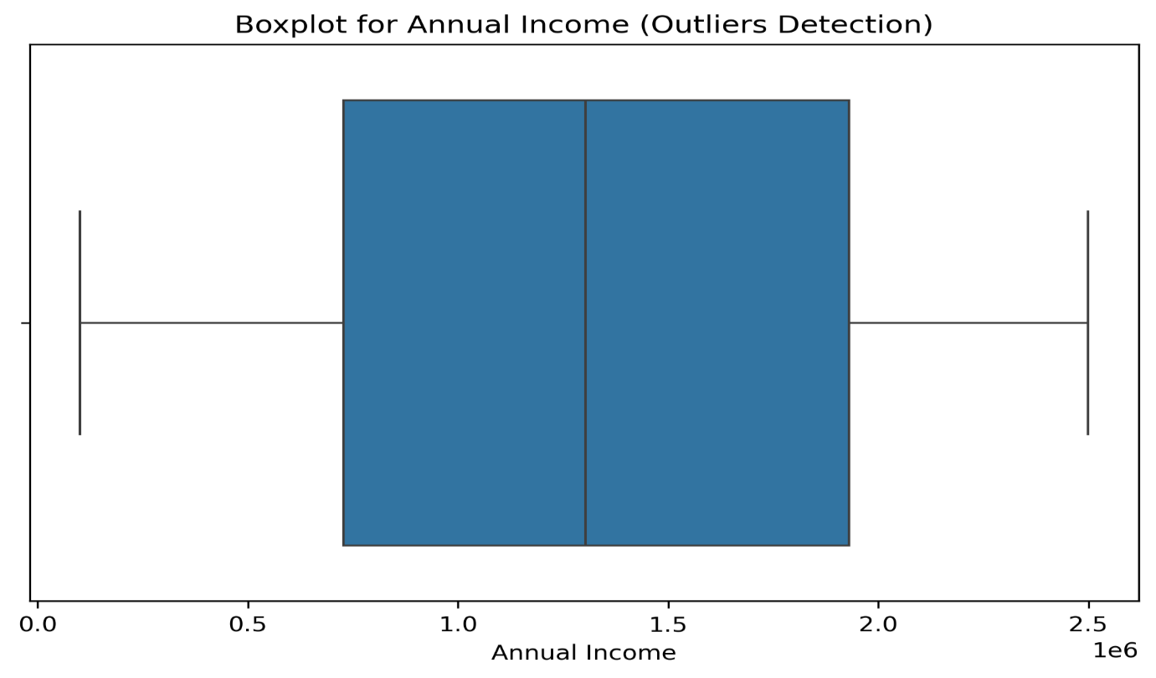
Fig 4:

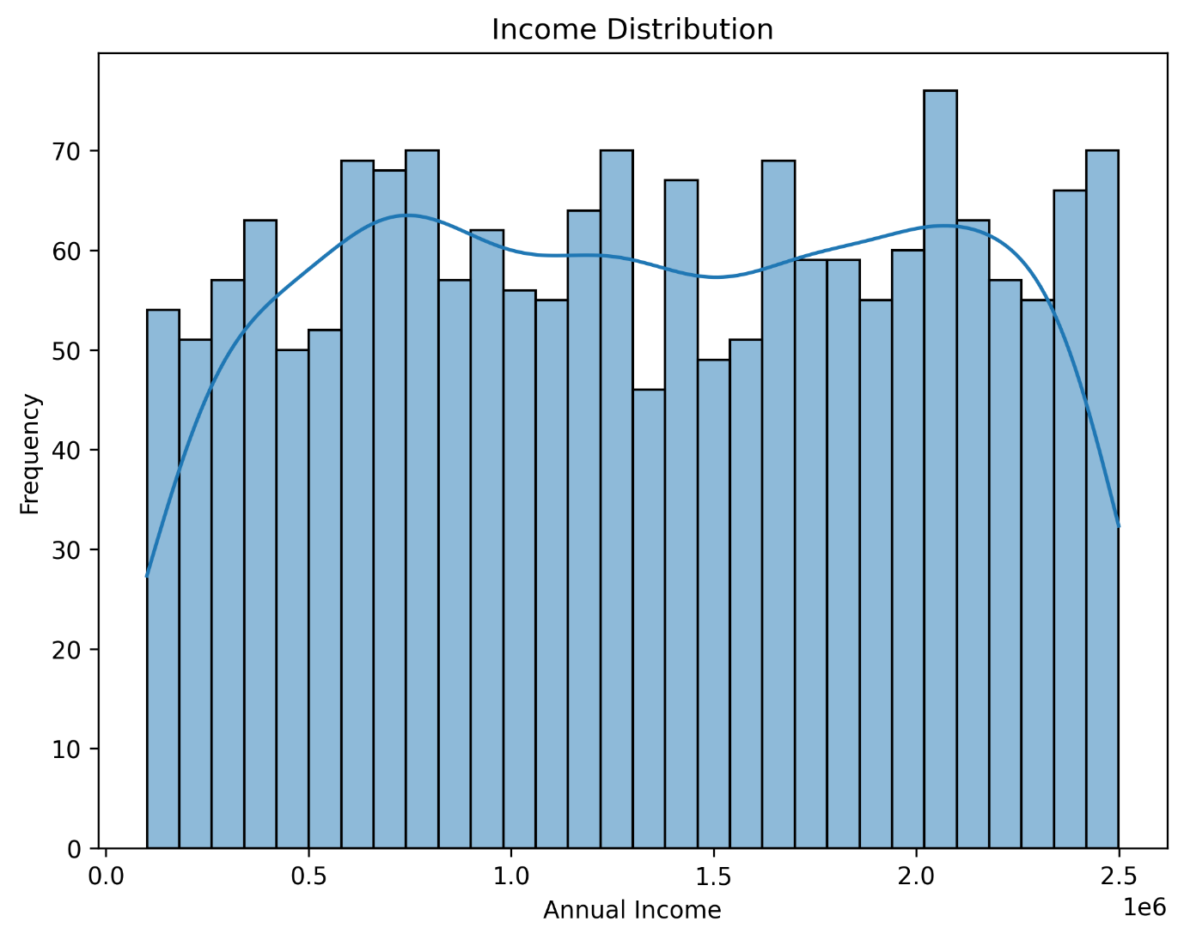

Fig 5:

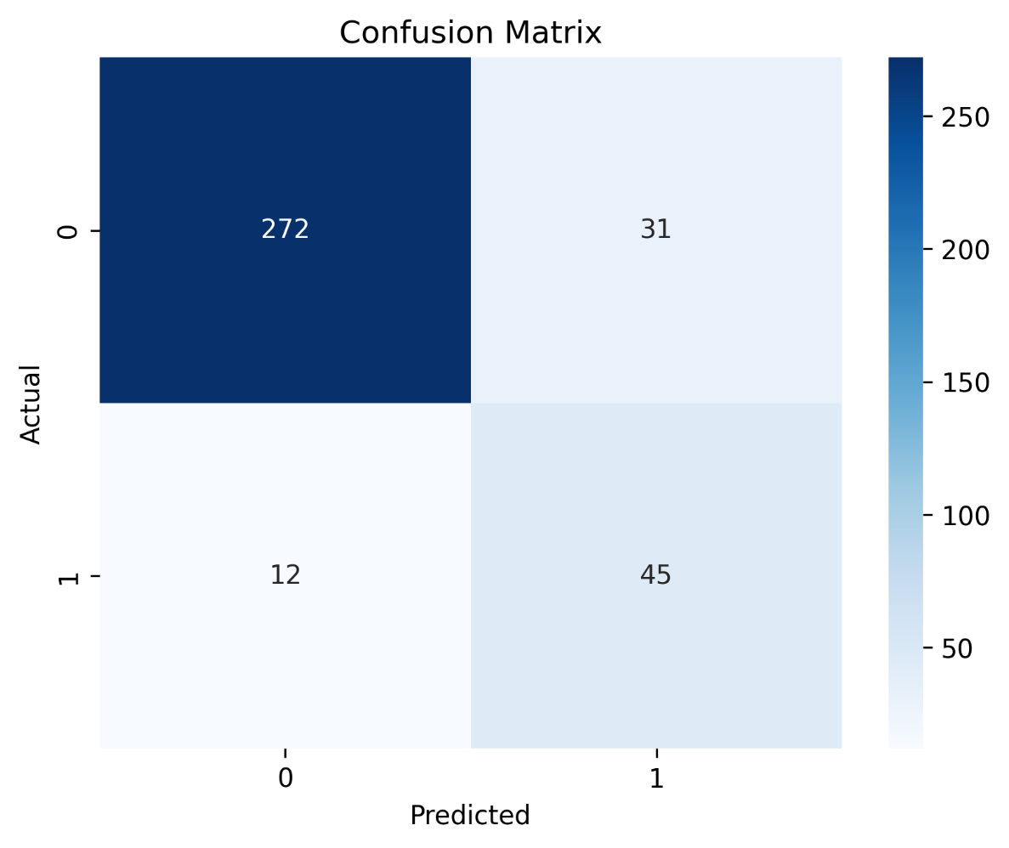

Fig 6:

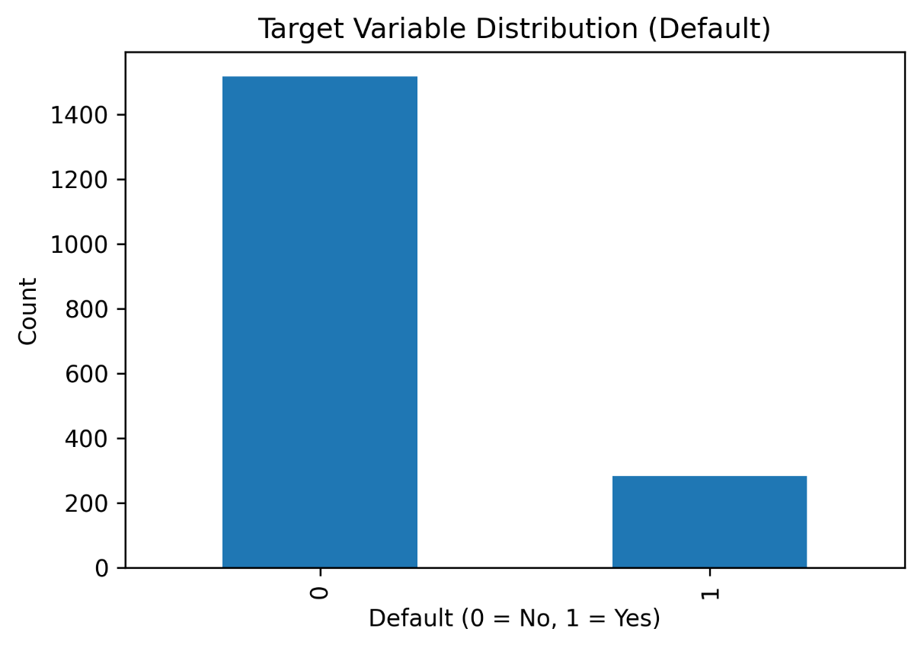

Fig 7: Classification Report

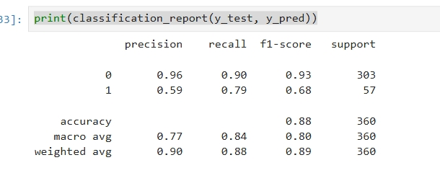

6. References:
Books:
- Yashavant Kanetkar, Let Us Python, BPB Publications

Online Resources:
- GeeksforGeeks – https://www.geeksforgeeks.org/
- TutorialsPoint – https://www.tutorialspoint.com/python/index.htm
- Stack Overflow – https://stackoverflow.com/

Documentation & Libraries:
- Scikit-learn Documentation – https://scikit-learn.org/
- Pandas Documentation – https://pandas.pydata.org/
- NumPy Documentation – https://numpy.org/
- Matplotlib Documentation – https://matplotlib.org/
- Seaborn Documentation – https://seaborn.pydata.org/
Imbalanced-learn (SMOTE) Documentation – https://imbalanced-learn.org/

